Battle of Assal Uttar September 10th, 1965.

Pakistan
5th Armored Brigade
HQ
6th Lancers (Patton) on right to Valtoha
A squadron
10 M-47 + 1 M-47 HQ
B squadron
7 M-47 + 1 M-47 HQ

24th Cavalry (Patton) to Assal Uttar
A squadron
10 M-47 + 1 M-47 HQ
B squadron
10 M-47 + 1 M-47 HQ

1 company armored infantry
11 M113
11 squads

India
4th Mountain Division.
4 x Infantry Company (10 squads, 3 x 3.5” Bazookas, 3 .30 cal mg) each
6 x 106mm Recoilless Rifles + jeep
Deccan Horse (Sherman) (14)
C Squadron
4 x troop of 3 Sherman M4 76mm
2 Sherman M4 76mm HQ

3rd Cavalry (Centurion) (28)
A, B Squadrons
4 x troop of 3 Centurion Mk III
2 Centurion Mk III HQ

8th Cavalry (AMX). (14)
A Squadron
4 x troop of 3 AMX-13 76mm
2 AMX-13 76mm HQ

Tactical Situation

Indians are set up as shown in sugar cane fields and towns. Squadrons are shown.

Orders: Hold line of defense and prevent Pakistani from taking Assal Uttar and moving north.

Pakistan enters along south edge of map.
Orders: Seize Assal Uttar and Valtoha and push on to Muhmudpura (off table).

Artillery:
Indians receive two batteries of artillery 24 pounders, and 2 FOs in jeeps.
Air Cover:
No air support as the sides are two close at this time to determine who is who.

Victory Conditions.
Pakistani:
Marginal Victory: Capture and hold until end Assal Uttar and Valtoha.
Overwhelming Victory: Move 6 or more tanks off on the map on roads where it says “to Mahmud Pura”.

Indian:
Marginal Victory: Prevent any sort of Pakistani victory condition.
Overwhelming Victory: Move 10 or more tanks off south edge on roads where it says ‘to Khem Karan” and prevent any sort of Pakistani victory.

Special Rules
The terrain in and around the fields is flooded (mud). The roads are considered 1 vehicle wide dirt tracks. They are mud when flooded. Sugar cane fields are dense woods for spotting except is only mid turret high. Thus spotting is as per hull down for size 1 and larger vehicles. For size 0 or less and infantry and AT weapons treat as dense woods for spotting. When flooded treat as mud for movement.

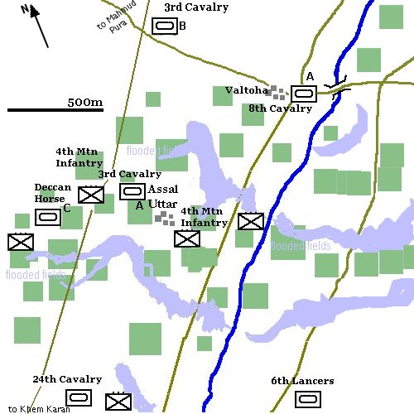

Random Conditions:
Each side rolls a D6 on the following tables to find what kind of random situation will occur. These can be secret or done in the open.

Pakistan
- Pakistani 24th Lancers are very low in fuel. After moving 200 roll a D6 each time they move. A ‘1’ means the vehicle runs out of fuel and is halted for remainder of the game.
- Pakistani troops are very demoralized. All vehicle morale bailout is +2 to bail. All troops are +2 to break.
- Pakistani command is confused. Tactical order may only be issued every other turn.
- 2 of the 3 infantry platoons refuse to advance.
- A FO in a jeep join the 24th Lancers. This controls an off-board battery of 4 105mm guns.
- A squadron of 9 M-48s join in support of the 24th Lancers.

India
- After setting up one random company of Indian infantry is lost in the high fields. Roll per platoon (3) for scatter as per indirect artillery except scatter is 100 x D10 in distance. This is the position the infantry must begin the game in.
- Indian artillery has been attacked by aircraft and is not available during the game.
- Flooding goes awry. Any tank starting in a flooded field rolls a D6. On a ‘1’ it remains stuck there the entire game.
- none
- none
- Air support of 2 jets with 2 500lb bombs can be called in as soon as Pakistani tanks move within 700 of Indian command positions.

History
Pakistani plan underway was to first seize Khem Karan and open the way for a rapid advance to the Beas River. The Beas had two bridges over it at this time Pakistan was to seize one bridge and then turn north. If successful, this maneuver would have isolated eleven divisions of the Indian Army, more than half its effective strength in the region. The way to Delhi would also have been open, a leisurely one-day drive. This was because India had no reserves, and no troops east of the Beas River.
As the scenario begins Khem Karan is taken, the next step is to advance to the Beas River, but first the low lying area between Khem Karan and the Beas River must be crossed.
The area north of Khem Karan consists of well-irrigated plains crossed by many waterways, dykes and other channels. The fields were high in sugar cane and other crops. The plains were easily flooded by breaching irrigation canals thus rendering the terrain unsuitable for mechanized advance. Four Centurion and Sherman squadrons were positioned to cover key roadways and approaches, forming a horseshoe into which the Indians expected the Pakistanis to march. Some squadrons were broken up into troops and allotted to the 4th Infantry Division, which formed the first line of defense in the village of Assal Uttar. The Indian 4th Infantry Division was equipped with jeep-mounted 106mm recoilless rifles, bazookas and other close-range anti-tank weapons, and the area to the division's rear was well covered by both artillery and the tank squadrons.

Results:
The commander of the Indian 2nd Independent Armored Brigade, Brig. Thang Raj, issued strict instructions to his tank crew to wait until the Pakistani tanks had approached quite close to their hull-down positions before opening fire so as to take advantage of the concealment offered by the thick sugar cane. The Pakistani tanks where much slowed down by the flooded terrain. Indian tanks and infantry AT teams ambushed them as they moved through the cane fields. The battle was a disaster for Pakistani armor while Indian losses were light.

